Type of the Paper (Article, Review, Communication, etc.)

Model reduction via nonlinear adaptive control

(You pasted this from dissertation…must retype/reword the ALL TEXT)

Timothy Sands 1,*

1 Department of Mechanical Engineering (CVN), Columbia University, USA

**\*** Correspondence: dr.timsands@caa.columbia.edu; Tel.: (831-656-3954)

Received: date; Accepted: date; Published: date

**Abstract:** A single paragraph of about 200 words maximum. For research articles, abstracts should give a pertinent overview of the work. We strongly encourage authors to use the following style of structured abstracts, but without headings: (1) Background: Place the question addressed in a broad context and highlight the purpose of the study; (2) Methods: Describe briefly the main methods or treatments applied; (3) Results: Summarize the article's main findings; and (4) Conclusions: Indicate the main conclusions or interpretations. The abstract should be an objective representation of the article, it must not contain results which are not presented and substantiated in the main text and should not exaggerate the main conclusions.

**Keywords:** keyword 1; keyword 2; keyword 3 (List three to ten pertinent keywords specific to the article; yet reasonably common within the subject discipline.)

1. Introduction

Motion mechanics is governed by Euler’s moment equations for three degrees of rotation of rigid bodies in space [1], and Newton’s Law [2] for three dimensions of translation. External forces produce a change of linear momentum (i.e. a change in velocity with time for a constant mass), while external torques produce a change in angular momentum (i.e. a change in angular velocity with time for a constant mass moment of inertia). Rigid body motion mechanics governing spacecraft attitude control has a long, distinguished lineage of literature [3-19].

Adaptive control algorithms often adapt control commands based upon errors tracking trajectories and/or estimation errors. Direct adaptive control algorithms typically directly adapt the control signal to eliminate tracking errors without estimation of unknown system parameters. Indirect adaptive control algorithms indirectly adapt the control signal by modifying estimates of unknown system parameters. The adaptation rule is derived using a proof that demonstrates the rapid elimination of tracking errors (the true objective). The proof must also demonstrate stability, which is complicated by the nonlinear closed loop system. Two fields of application of adaptive control is robotic manipulators and spacecraft maneuvers utilizing both approaches [20-22].

While some adaptive algorithms concentrate on adaptation of the feedback control, others have been suggested to modify a feedforward control command retaining a typical feedback controller, such as Proportional-Derivative (PD). Anderson evaluated the filtered-x LMS algorithm with FIR estimation for adaptation of feedforward command signals [23]. Simpler adaptation rules have been used for adaptation of the feedforward signal in the inertial reference frame [20]. “Hamiltonian Adaptive Control of Spacecraft” [21] presents such an inertial frame adaptive control. While the adaption is simpler in general form, the resulting regression model used in the control signal requires several pages to express for three-dimensional spacecraft rotational maneuvers (included in the appendix). This key reference presents a starting point for research presented here. Other references also utilizing the inertial frame [24] have been extended to include attitude control system power tracking in the control signal[25], but still suffer from the algorithmic complexity that accompanies the inertial frame. The regression matrix of “knowns” is required in the control calculation, so this approach is computationally inappropriate for spacecraft rotational maneuvers. Subsequently, Slotine’s 9-parameter estimation general approach was suggested for implementation in the body reference frame by Fossen [26]. The method was derived for slip translation of the space shuttle, but neither simulated nor experimentally verified.

Nonetheless, this method appears promising for practical implementation for three-dimensional spacecraft rotational maneuvers. System performance is enhanced by 1) updated inertia in the feedforward control signal, and 2) use of a reference trajectory that alters the desired trajectory using the tracking error. The Slotine-Fossen approach will be derived for 3-dimensional spacecraft rotational maneuvers, and then extended to produce two recommended alternatives for control and two alternatives for reference trajectories. Estimation requirements are reduced with new 6-parameter and 3-parameter regression models. Finally a modification to the approach demonstrates improved performance maintaining simplified models. After promising simulations, experimental verification is performed on a free-floating, three-axis spacecraft simulator.

2. Materials and Methods

Adaptive control for target tracking maneuvers begins with the basics Newton-Euler relationship for spacecraft attitude dynamics. Proposed improvement to existing techniques are suggested, so the theoretical development is firmly based in these existing techniques. Efforts are made to quickly summarize the theory of previous researchers then clearly indicate improved techniques.

Slotine [21-22] introduced an a nonlinear adaptive controller that modifies both feedforward and feedback control signals with inertia estimation and also by utilizing a reference trajectory which adds/subtracts commanded velocity to account for position error. This method of adaptive control is referred to as indirect adaptive control, and is referenced in this manuscript by the author’s name, Slotine. Control is indirectly adapted by explicitly estimating unknown parameters that are used to formulate the control. Direct adaptive control techniques reparametrize the control eliminating the explicit estimation of plant parameters and directly adapting the control signal itself. In the case of Slotine’s controller, the estimated plant parameters are in the control, so either term (direct/indirect) may arguably be used. For this paper, Slotine’s approach may also be referred to as indirect adaptive control. Slotine’s indirect adaptive control technique was compared favorably to feedback control alone (not combined feedforward/feedback as is typically done) [24]. One particular weakness was that one single matrix in the adaptive controller requires several pages to express [27] leading to unwieldy and unacceptable computations [26]. Subsequently, Fossen modified Slotine’s approach to solve the issue of unwieldy calculations. By determining the reference trajectory in the body coordinate frame versus the inertial coordinate frame as Slotine did, Fossen derived a substantial simplification. The method was not (at that time) derived for spacecraft rotational maneuvers, nor were simulations or experimental verification performed, but were subsequently done so by other colleagues [28], and this derivation relied on the reference trajectory originally used by Fossen. This manuscript will introduce options for reference trajectories that maintain the ability to use nonlinear adaptive control.

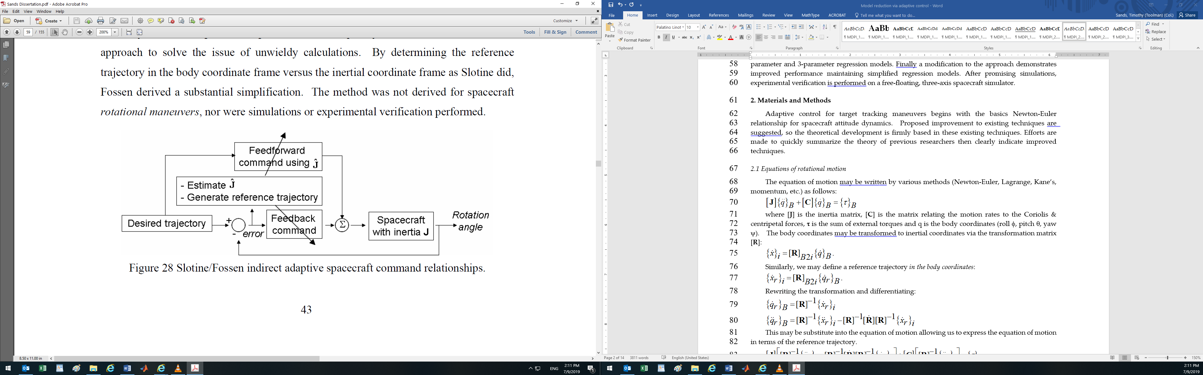

Figure 12. Topology of nonlinear adaptive control

2.1 Equations of rotational motion

The governing equations of motion may be written in matrix form by various methods (Newton-Euler, Lagrange, Kane’s, momentum, etc.) resulting in equation 1.

|  |  |
| --- | --- |
|  | (1) |

where [**J**] is the inertia matrix, [**C**] is the matrix relating the motion rates to the Coriolis & centripetal forces, **** is the sum of external torques and q is the body coordinates (roll , pitch , yaw ). The body coordinates may be transformed to *inertial coordinates* via the transformation matrix [**R**]:

|  |  |
| --- | --- |
|  | (2) |

Similarly, we may define a reference trajectory *in the body coordinates*:

|  |  |
| --- | --- |
|  | (3) |

Rewriting the transformation and differentiating, dropping the B2i subscript for brevity:

|  |  |
| --- | --- |
|  | (4) |

This may be substitute into the equation of motion allowing us to express the equation of motion in terms of the reference trajectory which may be distributed as so.

|  |  |
| --- | --- |
|  | (5) |
|  | (6) |

Pre-multiplying by allows us to understand [Slotine]’s original approach **Error! Reference source not found.**:

|  |  |
| --- | --- |
|  | (7) |
|  | (8) |
|  | (9) |

Slotine uses the linear regression model to define an equivalent system based on parameter estimates:

|  |  |
| --- | --- |
|  | (10) |

The estimates are adapted using an adaption rule that makes the closed loop system stable in the Lyapunov sense. The regression model is then used in the control, which is where the complication arises. The matrix of “knowns” occupies several pages [REFERENCE SANDS APPENDIX] and is used *at each time* step to formulate the adapted control signal making the method computationally impractical. [Fossen] on the other hand formulates the regression model in the *body coordinates* eliminating the complications seen above with the numerous multiplications with the coordinate transformation matrix [**S**]. Picking up from [Slotine]’s method above, we can simply express the regression model *including* the transformation matrix.

|  |  |
| --- | --- |
|  | (11) |

Note Fossen’s matrix of “knowns” has no asterisk. Preface [Slotine]’s mathematical trick (pre-multiplication) above.

|  |  |
| --- | --- |
|  | (12) |

Continuing here yields [Fossen]’s substantial simplification through the following 3 steps:

1. Solve the earlier defined transformation equations for :



|  |  |
| --- | --- |
|  | (13) |
|  | (14) |

1. Instead of pre-multiplying , substitute into equation (12) repeated here overtly as equation (15).

|  |  |
| --- | --- |
|  | (15) |

1. Reduce this to linear regression form:

|  |  |
| --- | --- |
|  | (16) |
|  | (17) |

All that remains now is to multiply this out and regroup the terms into the linear regression model.

|  |  |
| --- | --- |
|  | (18) |

In order to do this, we must define the reference trajectory. The modifications to the overall feedforward control strategy may be embodied in these two venues: 1) estimate/adapt estimates of inertia in the regression model above, and 2) choose a reference trajectory that addresses system lead/lag when applying the assumed control to a spacecraft with modeling errors, disturbances and noise.

2.2 Reference trajectory

Define the reference trajectory such that the control helps the spacecraft “catch up” to the commanded trajectory. If the spacecraft is actually heavier than modeled, it needs a little extra control to achieve tracking than will be provided by classical feedforward control. If the spacecraft is actually lighter than modeled, the control must be reduced so as not to overshoot the commanded trajectory. Consider defining the reference trajectory as follows.

|  |  |
| --- | --- |
|  | (19) |
|  | (20) |

Note we have scaled the reference acceleration and velocity to add/subtract the velocity and position error respectively scaled by a positive definite constant, . This should help the feedforward control component regardless of indirect adaption. Notice the example in Figure 1. The reference trajectory sometimes leads the desired trajectory (when the spacecraft is lagging behind the desired). The reference trajectory also sometimes lags the desired trajectory (when the spacecraft is leading the desired trajectory). Accordingly, subsequent sections will evaluate the effectiveness of the reference trajectory by itself and the also the indirect adaption/estimation by itself as well. First, let’s conclude the derivation by multiplying out the linear regression form so that the reader can have the simple equation for spacecraft rotational maneuvers.

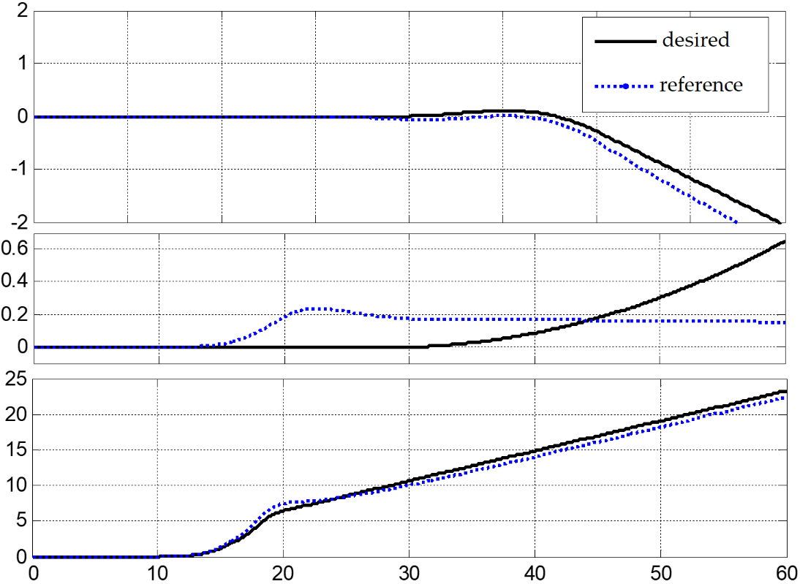

**Figure 1** Reference Trajectory (blue-dotted line) compared with desired trajectory (solid-black line). Notice reference sometimes leads and sometimes lags desired trajectory (based on tracking error). Time in seconds on the abscissa versus angular rotation in degrees.

2.2.1. Incorporation of reference trajectory

Simplify equation 17 by substituting reference trajectory with and , and then manipulate the linear algebra to reveal the two-degree-of-freedom nature of the control: All this effort may be simplified to an adaptive feedforward controller together with a reference trajectory feedback.

|  |  |
| --- | --- |
|  | (21) |
|  | (22) |
|  | (23) |

whereis the skew symmetric matrix form of the momentum vector. Expand equation (23)



|  |  |
| --- | --- |
|  | (24) |

Where the relationship is approximated by , an appropriate augmentation of the control results per equation (25)

|  |  |
| --- | --- |
|  | (25) |

Multiplying out equation (25) produces equation (26):

|  |  |
| --- | --- |
|  | (24) |

Formulate a companion to equation (18) in equation (26) by assuming symmetric inertia matrix and assigning equation (24) and (25 as so.

|  |  |
| --- | --- |
|  | (24) |
|  | (25) |
|  | (26) |

This is the derivation of Fossen’s modification of Slotine’s indirect adaptive feedforward control not currently in the literature (Referred to as Slotine/Fossen). Using this regression model, we are free to evaluate the first substantial contribution in this portion of this dissertation. After comparing this approach to classical feedforward and feedback control, this model will be the basis upon which proposed improvements are made.



The dynamics establish the classical feedforward command when the inertia is known and correct. Accordingly, utilize the estimated dynamics for formulate the adapted feedforward command based on estimated inertia. Additionally, feedback control may be added utilizing the reference trajectory in a PD control architecture.



Notice this definition of feedback control defines the reference trajectory gain = Kp /Kd. Thus choice of Kp and Kd constrains/defines the refence trajectory. This fact will be utilized later to improve the method.



Similar to the example in **Error! Reference source not found.**, *feedforward* techniques in this study are compared by fixing feedback gains: . This causes a limitation in adaption of the feedforward torque, since the regression model is formulated using the *reference* trajectory. The proposed technique is to feedback the desired trajectory rather than the reference trajectory. This allows the reference trajectory to be more aggressively used to adapt the feedforward control without effecting the feedback signal.



2.3 Stability analysis **USE THIS TO ILLUSTRATE HOW ONLY ONE  IS PERMITTED CONTRARY TO YOUR HAMILTONIAN PAPER (by citation)**

Global asymptotic stability is demonstrated with a Lyapunov argument for angle position control with rate regulation. Consider the energy-like function where refers to angle and rate in generalized body coordinates, refer to angle and rate errors ( & ), with estimates , and a positive constant gain . Note in Hamiltonian form (energy transfers) conservation of energy yields: where [**J**] is the inertia matrix and {**** } is applied control torque. Using this neat trick for substitution and differentiating:



. Define the control and substitute into .



Now, define the estimation rate .



Per Lyapunov stability theory, for positive definite function *V* (continuously differentiable, , ), guarantees asymptotic stability. Since *V*(**q**) is radially unbounded (), global asymptotic stability is assured if we assert that . The system cannot get stuck at a non-zero position since acceleration is non-zero, so invariant set theorem affirms the system is globally asymptotically stable.



2.4 Nonlinear adaptive control parameterizations

2.4.1 6-parameter regression

Recalling {**H}**=[**J]{**}, substitution into the 9-parameter regression model allows reformulation into the following equivalent 6-parameter regression model.



It is proposed to no longer estimate the rate (since we have rate sensors), and instead estimate *only* the unknown inertia terms. The first proposed adaptive technique (*Proposed6*) utilizes this regression model and implements fixed fb and variable ff.

2.4.2 3-parameter regression

Typical assumptions for simplified spacecraft dynamics modeling include neglecting inertia cross-products. The result is the following regression model.



The second proposed adaptive technique (*Proposed3*) utilizes this regression model and implements fixed fb and variable ff.

While the developments so far simplify the promising Slotine/Fossen approach, it is noted that λ defines the reference trajectory which is fed to both feedback and feedforward controls. Recall that ideal feedforward control perfectly achieves commanded maneuvers if the modeled inertia is exactly equal to the actual inertia. Feedback control is useful to catch the errors after they have already been incurred. The Slotine/Fossen approach does not feedback the desired, commanded trajectory. The feedback signal is calculated based on error tracking the more aggressive (leading/lagging) reference trajectory. It is intuitive to make a more aggressive feedforward signal if your inertia estimate is low, and a less aggressive feedforward signal if your inertia estimate is high. But feedback controls are attempting to fix the attitude at the next time step with error based on the previous time step without using knowledge of upcoming trajectory which could be in an arbitrary direction. It is proposed that using the correct, desired trajectory to define the error in the feedback control while maintaining the reference trajectory for adaptive feedforward should result in lower tracking error.

This is accomplished by introducing a λff to be used in the feedforward signal identically as λ previously derived in the Slotine/Fossen method. For feedback, λfb will be fixed to equate to normal PD (desired trajectory) feedback control per:

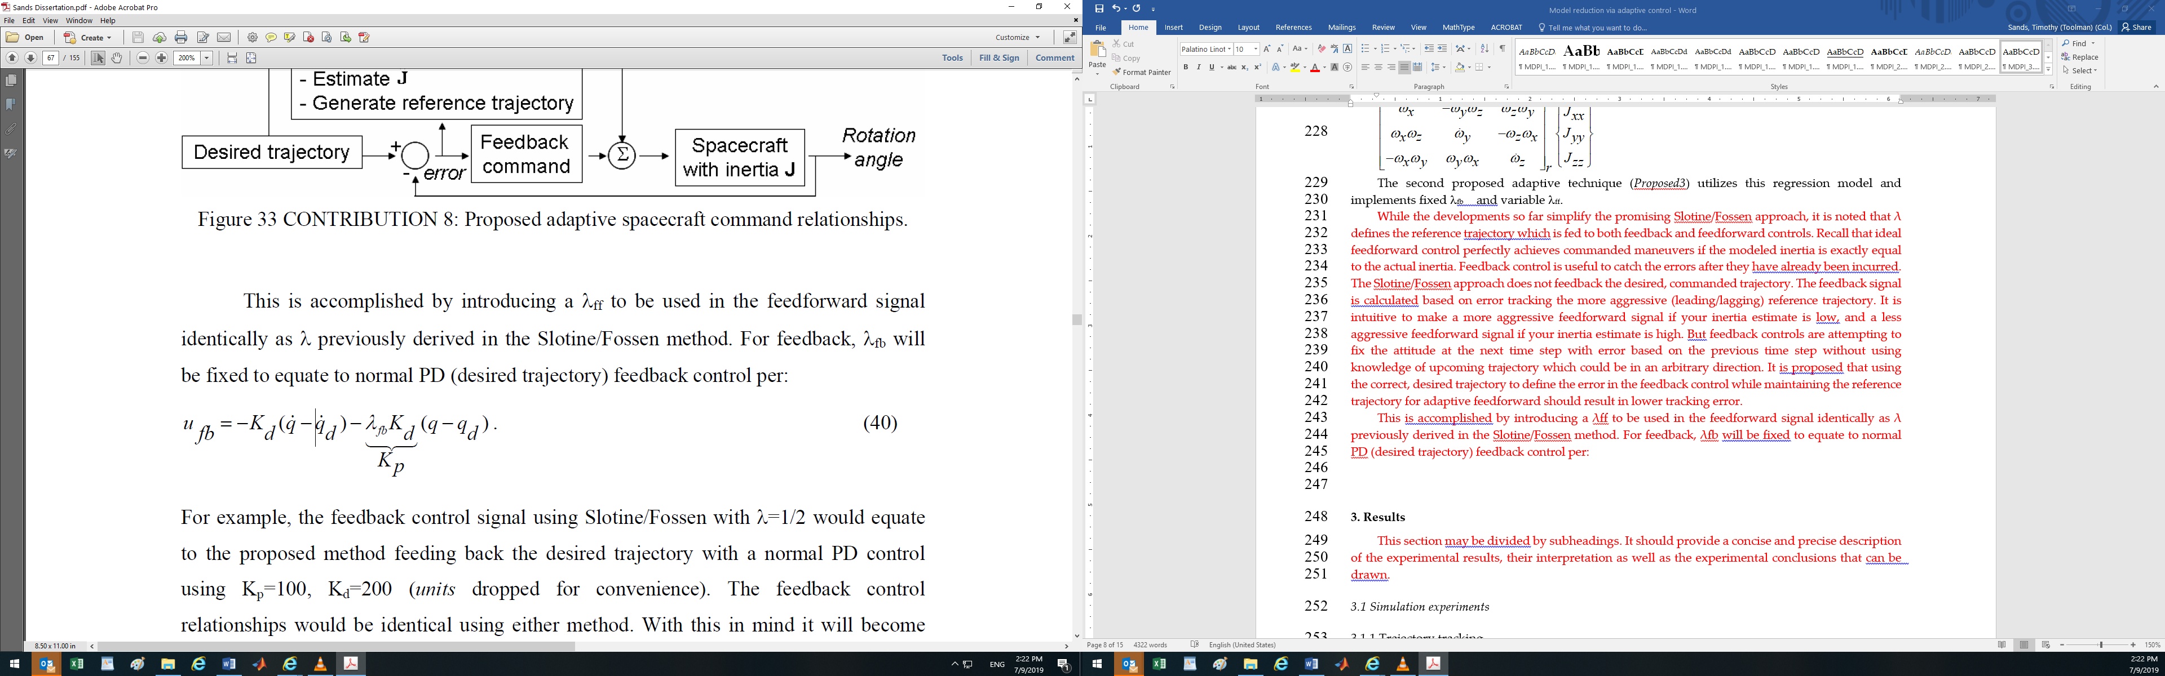

For example, the feedback control signal using Slotine/Fossen with λ=1/2 would equate to the proposed method feeding back the desired trajectory with a normal PD control using Kp=100, Kd=200 (units dropped for convenience). The feedback control relationships would be identical using either method. With this in mind it will become clear that increasing λff will result in relative improvement.

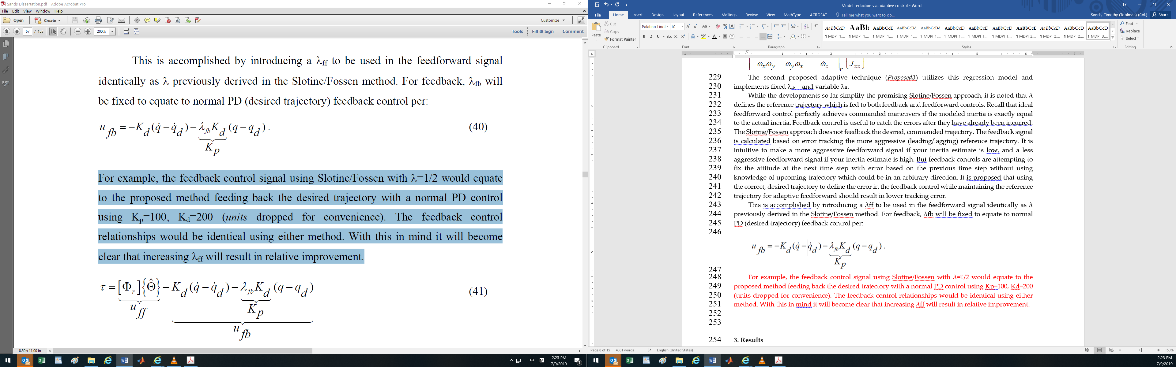

3. Results

This section may be divided by subheadings. It should provide a concise and precise description of the experimental results, their interpretation as well as the experimental conclusions that can be drawn.

3.1 Simulation experiments

3.1.1 Trajectory tracking

In this section, a nominal acquisitions, tracking and pointing maneuver is simulated. Following an initial maneuver to acquire the target with a brief settling maneuver, target tracking maneuver is performed with various control techniques to compare performance. The maneuver consists of a steady yaw (earth-tracking maneuver) with slight roll (target run) and sinusoidal pitch (target evasion). Older estimated values of the experimental testbed’s inertia (prior to installation of the optical payload) are used to design the feedforward torque command. Since the actual new inertia is unknown, the simulated “actual” inertia components were modified to match the experimental RMS errors. Simulated spacecraft inertia [J]actual-simulated was increased 10% arbitrarily from what was assumed in the design of the feedforward control [J]feedforward.

|  |  |
| --- | --- |
|  | (1) |

After 10 seconds of initial regulation (from to ), the desired target acquisitions trajectory is designed to take eight seconds with a two second settling maneuver leading to the (evasive) target tracking maneuver.

|  |  |
| --- | --- |
|  | (1) |

The Euler angles that result from this inertia acceleration are depicted in Fig 17.

|  |  |
| --- | --- |
| (a) SIMULATION: DESIRED TRAJECTORY - Desired target tracking trajectory (roll , pitch , yaw in degrees) | (**b**) Simulation: Classical control comparison. Tracking errors (roll , pitch , yaw in degrees) comparison: Classical feedforward Vs. Classical feedforward Vs. Classical feedforward + PD feedback control. |

Figure 1. Simulation: 10% Inertia Error for large-angle acquisition maneuver followed by target tracking trajectory. Spacecraft actual inertia (6) components are 10% higher than designed in classical feedforward design.

**Table 1.** 60 second ATP Simulation, [J] error=10%.

|  |  |  |  |
| --- | --- | --- | --- |
|  | ϕ |  |  |
| Classical only | 0.1026 | 0.0170 | 0.9328 |
| only | 0.0128 | 0.0126 | 0.0518 |
| Classical , | 0.0012 | 0.0011 | 0.0047 |
| [Slotine/Fossen]: , , | 0.0028 | 0.0008 | 0.0042 |
| Proposed6: , , , | 0.0027 | 0.0006 | 0.0036 |
| Proposed3: , , , | 0.0035 | 0.0077 | 0.0034 |

|  |  |
| --- | --- |
| (a) Angular rate comparisons | (**b**) Euler angle comparisons |

Figure 1. Simulation: comparisons for acquisitions, tracking, and pointing (ATP) trajectory **(IS THIS CONTROL OR EULER ANGLE ERROR??)**

|  |  |
| --- | --- |
| (a) Adaptive control comparisons | (**b**) Adaptive control comparisons |

Figure 1. Simulation: comparisons for acquisitions, tracking, and pointing (ATP) trajectory **(IS THIS CONTROL OR EULER ANGLE ERROR??)**

|  |  |
| --- | --- |
| (a) Simulation: 3-parameter estimates | (**b**) Simulation: 6-parameter estimates |

Figure 1. TASS2 free-floating experimental testbed at the Naval Postgraduate School used for experimental validation of the claims in this manuscript

**Table 2.** 60 second ATP Simulation, [J] error=30%.

|  |  |  |  |
| --- | --- | --- | --- |
|  | ϕ |  |  |
| Classical only | 0.2742 | 0.0489 | 2.3676 |
| only | 0.0150 | 0.0152 | 0.0614 |
| Classical , | 0.0035 | 0.0035 | 0.0142 |
| [Slotine/Fossen]: , , | 0.0047 | 0.0021 | 0.0120 |
| Proposed6: , , , | 0.0046 | 0.0014 | 0.0101 |
| Proposed3: , , , | 0.0055 | 0.0090 | 0.0099 |

1 Root mean square errors measured in degree

General qualitative conclusions may be drawn from the ideal (no noise) simulations. Classical feedforward control should not be used unless the inertia is exactly known. PD Feedback alone can accomplish the maneuver, but combined classical feedforward and PD feedback control is much better by an order of magnitude. Slotine/Fossen’s adaptive techniques can improve performance slightly more while also providing updated inertia estimates. Furthermore, a simplified 6-parameter estimation algorithm retains the performance of Slotine/Fossen’s method with further slight improvements. Defining the reference trajectory independently for feedforward and feedback controls allows further performance increase. In the case used here (significant off-diagonal inertia terms), a proposed 3-parameter identification does not improve performance, but remains a viable option for cases where a diagonal inertia matrix assumption is valid.

Slotine’s Hamiltonian Adaptive Control of Spacecraft [36] introduced a promising general methodology for nonlinear adaptive control of spacecraft with inertia estimation. The technique was handicapped by its derivation in the inertial reference frame. Fossen’s Comments on Hamiltonian Adaptive Control of Spacecraft suggested equivalent formulation in the body reference frame, considerably reducing algorithmic complexity. Fossen’s formulation is derived and demonstrated to improve performance compared to classical feedforward, feedback, and classical feedforward with feedback controls. Furthermore an improvement is presented that utilizing the desired trajectory in the feedback control while maintaining the reference trajectory in the feedforward control. This improves performance further compared to all control methods. Two alternative formulations are presented to further simplify the computational complexity. When a diagonal inertia matrix may be appropriately used to approximate the spacecraft inertia, a mere-three parameter adaptive control is recommended based on these results. As with the case presented here (non-negligible inertia cross products), a six-parameter adaptive control can be utilized

3.3 Experimental validation on free-floating spacecraft simulator

Description of the experimental hardware is based in [40] whose graphics were directly replicated here. Notice in Fig 22 - Fig 23 the satellite simulator is composed of a spacecraft bus (bottom) with an optical payload mounted on the upper deck. Initial inertia estimates used in the adaptive control presented earlier were values experimentally estimated prior to installation of the upper payload deck. The upper payload deck is fixed to the satellite, so the spacecraft attitude control system must guarantee the payload bore sight is maintained. The ground/air/space based source laser is received through the lower telescope and optically relayed to the upper telescope for transmission to the target. The upper telescope is mounted on a small platform that gimbals with respect to the spacecraft and lower payload deck. This fourth degree of freedom allows the spacecraft to maintain source laser pointing in three dimensions and simultaneously track a moving target.

|  |  |
| --- | --- |
| TASS2%20Equipment%20locations  (a) CAD: Free-floating 3-axis satellite simulator | TASS2%20Testbed  (**b**) PHOTO: Free-floating 3-axis satellite simulator |

Figure 1. TASS2 free-floating experimental testbed at the Naval Postgraduate School used for experimental validation of the claims in this manuscript

Actual spacecraft inertia (6) components are unknown. Older estimated inertia values (prior to payload installation) are used for classical control design and initializing adaptive controllers. The identical acquisitions and target tracking maneuver simulated above is commanded on the Naval Postgraduate School’s three-axis satellite simulator 2 (TASS2).

|  |  |
| --- | --- |
| (a) Experiment: classical control comparison - classical feedback versus classical feedforward with PD feedback control | (**b**) Experiment: adaptive control techniques comparison |

Figure 1. Large-angle acquisition maneuver followed by target tracking trajectory: Tracking errors (roll , pitch , yaw  in degrees) comparison

|  |  |
| --- | --- |
| (a) CAD: Free-floating 3-axis satellite simulator | (**b**) PHOTO: Free-floating 3-axis satellite simulator |

Figure 1. EXPERIMENT: ADAPTIVE CONTROL COMPARISON: For large-angle acquisition maneuver followed by target tracking trajectory: Tracking errors (roll , pitch , yaw  in degrees) comparison: [Slotine/Fossen] adaptive feedforward & PD feedback control, Proposed6 adaptive feedforward (ff=1) & PD feedback control, Proposed3 adaptive feedforward (ff=1) & PD feedback control.



Fig 2 EXPERIMENT: INERTIA ESTIMATION: Inertia estimates using Proposed6 adaptive feedforward uff + ufb: Kp=100,Kd=200.

**Table 3.** 60 second laboratory hardware experiment

|  |  |  |  |
| --- | --- | --- | --- |
|  | ϕ |  |  |
| [Slotine/Fossen]: , , | 0.149 | 0.058 | 0.248 |
| Proposed6: , , , | 0.124 | 0.048 | 0.145 |
| Proposed3: , , , | 0.102 | 0.103 | 0.142 |

1 Root mean square errors measured in degree

4. Discussion

Authors should discuss the results and how they can be interpreted in perspective of previous studies and of the working hypotheses. The findings and their implications should be discussed in the broadest context possible. Future research directions may also be highlighted.

**Funding:** This manuscript received no external funding. The author solely funded the APC.

**Acknowledgments:** Special thanks to professors Jae June Kim and Brij Agrawal of the Naval Postgraduate School for technical support, particularly materials used for experiments.

**Conflicts of Interest:** The author declare no conflict of interest.

References (MUST UPDATE TO MDPI FORMAT)

1. Euler, L. (Euler) Formulae Generales pro Translatione Quacunque Corporum Rigidorum (General Formulas for the Translation of Arbitrary Rigid Bodies), Presented to the St. Petersburg Academy on 9 October 1775. and First Published in Novi Commentarii Academiae Scientiarum Petropolitanae 20, 1776, pp. 189–207 (E478) and Was Reprinted in Theoria motus corporum rigidorum, ed. nova, 1790, pp. 449–460 (E478a) and Later in His Collected Works Opera Omnia, Series 2, Volume 9, pp. 84–98. Available online: https://math.dartmouth.edu/~euler/docs/originals/E478.pdf (accessed on 22 August 2018).
2. Newtono, I., Philosophia Naturalis Principia Mathematica. 1687 (in New Latin). 1728 (English). Reprinted by Kessinger Publishing, LLC (June 2, 2008). ISBN: 0548952612.
3. Thompson, W.; Tait, P.G. Elements of Natural Philosophy; Cambridge University Press: Cambridge, UK, 1872.
4. Reuleaux, F.; Kennedy Alex, B.W. The Kinematics of Machinery: Outlines of a Theory of Machines; Macmillan: London, UK, 1876; Available online: https://archive.org/details/kinematicsofmach00reuluoft (accessed on 22 August 2018).
5. Wright, T.W. Elements of Mechanics Including Kinematics, Kinetics and Statics; D. Van Nostrand Company: New York, NY, USA; Harvard University: Cambridge, MA, USA, 1896.
6. Merz, J.T. A History of European Thought in the Nineteenth Century; Blackwood: London, UK, 1903; p. 5.
7. Whittaker, E.T. A Treatise on the Analytical Dynamics of Particles and Rigid Bodies; Cambridge University Press: Cambridge, UK, 1904.
8. Whittaker, E.T. A Treatise on the Analytical Dynamics of Particles and Rigid Bodies; Cambridge University Press: Cambridge, UK, 1917.
9. Whittaker, E.T. A Treatise on the Analytical Dynamics of Particles and Rigid Bodies; Cambridge University Press: Cambridge, UK, 1927.
10. Whittaker, E.T. A Treatise on the Analytical Dynamics of Particles and Rigid Bodies; Cambridge University Press: Cambridge, UK, 1937.
11. Church, I.P. Mechanics of Engineering; Wiley: New York, NY, USA, 1908; p. 111.
12. Wright, T.W. Elements of Mechanics Including Kinematics, Kinetics, and Statics, with Applications; Nostrand: New York, NY, USA, 1909.
13. Study, E. ; Delphenich, D.H., Translator; Foundations and goals of analytical kinematics. Sitzber. d. Berl. Math. Ges. 1913, 13, 36–60. Available online: http://neo-classical-physics.info/uploads/3/4/3/6/34363841/study-analytical_kinematics.pdf (accessed on 14 April 2017).
14. Gray, A. A Treatise on Gyrostatics and Rotational Motion; MacMillan: London, UK, 1918; ISBN 978-1-4212-5592-7. (Published 2007).
15. Rose, M.E. Elementary Theory of Angular Momentum; John Wiley & Sons: New York, NY, USA, 1957; ISBN 978-0-486-68480-2. (Published 1995). [Google Scholar]
16. Kane, T.R. Analytical Elements of Mechanics Volume 1; Academic Press: New York, NY, USA; London, UK, 1959.
17. Kane, T.R. Analytical Elements of Mechanics Volume 2 Dynamics; Academic Press: New York, NY, USA; London, UK, 1961.
18. Thompson, W. Space Dynamics; Wiley and Sons: New York, NY, USA, 1961. [Google Scholar]
19. Greenwood, D. Principles of Dynamics; Prentice-Hall: Englewood Cliffs, NJ, USA, 1965; ISBN 9780137089741. (Reprinted in 1988 as 2nd ed.).
20. G. Niemeyer and J.J.E. Slotine, “Performance in adaptive manipulator control,”Proceedings of 27th IEEE Conference on Decision and Control, December, 1988.
21. J.J.E Slotine and M.D. Benedetto, “Hamiltonian Adaptive Control of Spacecraft,”IEEE Transactions on Automatic Control, Vol. 35, 848-852, July 1990.
22. J.J.E. Slotine W. Li, Applied Nonlinear Control, Prentice-Hall, Upper Saddle River, NJ, 1991, 422-433.
23. E.H. Anderson, “Adaptive Feedforward Control for Actively Isolated Spacecraft Platforms,” AIAA Structures, Structural Dynamics, and Materials Conference and Exhibit, Kissimmee, Apr 7-10, 1997: AIAA-1997-1200.
24. J.J.E. Slotine W. Li, Applied Nonlinear Control, Prentice-Hall, Upper Saddle River, NJ, 1991, 422-433.
25. H. Yoon and P. Tsiotras, “Spacecraft Adaptive Attitude and Power Tracking with Variable Speed Control Moment Gyroscopes,” Journal of Guidance, Control, and Dynamics, Vol. 25, No.6, Nov-Dec 2002.
26. T. Fossen, “Comments on ‘Hamiltonian Adaptive Control of Spacecraft,’” IEEE Transactions on Automatic Control, Vol. 38., No. 4, April 1993.
27. Sands, T. Fine Pointing of Military Spacecraft. PhD Dissertation, Naval Postgraduate School, Monterey, March 2007.
28. Sands, T., Kim, J., Agrawal, B. Spacecraft Adaptive Control Evaluation. Proceedings of Infotech@Aerospace, Garden Grove, CA, USA, 19-21 June 2012; American Institute of Aeronautics and Astronautics, Reston, VA, USA.
29. Author 1, A.B.; Author 2, C.D. Title of the article. *Abbreviated Journal Name* **Year**, *Volume*, page range.
30. Author 1, A.; Author 2, B. Title of the chapter. In *Book Title*, 2nd ed.; Editor 1, A., Editor 2, B., Eds.; Publisher: Publisher Location, Country, 2007; Volume 3, pp. 154–196.
31. Author 1, A.; Author 2, B. *Book Title*, 3rd ed.; Publisher: Publisher Location, Country, 2008; pp. 154–196.
32. Author 1, A.B.; Author 2, C. Title of Unpublished Work. *Abbreviated Journal Name* stage of publication   
    (under review; accepted; in press).
33. Author 1, A.B. (University, City, State, Country); Author 2, C. (Institute, City, State, Country). Personal communication, 2012.
34. Author 1, A.B.; Author 2, C.D.; Author 3, E.F. Title of Presentation. In Title of the Collected Work (if available), Proceedings of the Name of the Conference, Location of Conference, Country, Date of Conference; Editor 1, Editor 2, Eds. (if available); Publisher: City, Country, Year (if available); Abstract Number (optional), Pagination (optional).
35. Author 1, A.B. Title of Thesis. Level of Thesis, Degree-Granting University, Location of University, Date of Completion.
36. Title of Site. Available online: URL (accessed on Day Month Year).

|  |  |
| --- | --- |
| copyRight | © 2019 by the authors. Submitted for possible open access publication under the terms and conditions of the Creative Commons Attribution (CC BY) license (http://creativecommons.org/licenses/by/4.0/). |